**CSE423: Computer Graphics**

**Project Submission**

***Project Name: Jurassic Jump***

***Group: 11***

**Group Members**

Name: Abrar Ahmed

ID: 21301309

Name: Zarin Tasnim Raisa

ID: 21301022

Name: Md. Mezbha Ul Haq Fahim

ID: 21301243

***Section: 01***

***Source Code:***

from OpenGL.GL import *

from OpenGL.GLUT import *

from OpenGL.GLU import *

start_time = 0

listfortimeprint = []

gameOver = False

dinosaur_jump = 0

goingUP = False

goingDOWN = False

movingCactus1 = 0

cactus_1 = 2000

cactus = 3000

cactus1 = 5000

speed = 1

seconds = 0

bird_x = 1500

bird_y = 4500

bird_speed = 15

def dinosaur():

glColor3f(0.4, 0.0, 0.5)

#head

midpoint(90, 200 + dinosaur_jump, 105, 200 + dinosaur_jump)

midpoint(90, 200 + dinosaur_jump, 90, 195 + dinosaur_jump)

midpoint(85, 195 + dinosaur_jump, 90, 195 + dinosaur_jump)

midpoint(85, 195 + dinosaur_jump, 85, 190 + dinosaur_jump)

midpoint(80, 190 + dinosaur_jump, 85, 190 + dinosaur_jump)

midpoint(80, 190 + dinosaur_jump, 80, 110 + dinosaur_jump)

midpoint(105, 200 + dinosaur_jump, 105, 195 + dinosaur_jump)

midpoint(105, 195 + dinosaur_jump, 112, 195 + dinosaur_jump)

midpoint(112, 195 + dinosaur_jump, 112, 190 + dinosaur_jump)

midpoint(112, 190 + dinosaur_jump, 117, 190 + dinosaur_jump)

midpoint(117, 190 + dinosaur_jump, 117, 185 + dinosaur_jump)

midpoint(117, 185 + dinosaur_jump, 125, 185 + dinosaur_jump)

midpoint(125, 185 + dinosaur_jump, 125, 180 + dinosaur_jump)

midpoint(125, 180 + dinosaur_jump, 130, 180 + dinosaur_jump)

midpoint(130, 180 + dinosaur_jump, 130, 160 + dinosaur_jump)

midpoint(125, 160 + dinosaur_jump, 130, 160 + dinosaur_jump)

midpoint(125, 160 + dinosaur_jump, 125, 155 + dinosaur_jump)

midpoint(105, 155 + dinosaur_jump, 125, 155 + dinosaur_jump)

#eye

midpointCircle(2, 98, 181 + dinosaur_jump) #Midpoint Circle Algorithm Part

#body

midpoint(105, 155 + dinosaur_jump, 105, 115 + dinosaur_jump)

midpoint(105, 115 + dinosaur_jump, 110, 115 + dinosaur_jump)

midpoint(110, 115 + dinosaur_jump, 110, 110 + dinosaur_jump)

midpoint(110, 110 + dinosaur_jump, 115, 110 + dinosaur_jump)

midpoint(115, 110 + dinosaur_jump, 115, 70 + dinosaur_jump)

midpoint(110, 70 + dinosaur_jump, 115, 70 + dinosaur_jump)

midpoint(110, 70 + dinosaur_jump, 110, 65 + dinosaur_jump)

midpoint(102, 65 + dinosaur_jump, 110, 65 + dinosaur_jump)

midpoint(102, 65 + dinosaur_jump, 102, 60 + dinosaur_jump)

midpoint(47, 60 + dinosaur_jump, 90, 60 + dinosaur_jump)

midpoint(50, 110 + dinosaur_jump, 80, 110 + dinosaur_jump)

midpoint(50, 110 + dinosaur_jump, 50, 105 + dinosaur_jump)

midpoint(45, 105 + dinosaur_jump, 50, 105 + dinosaur_jump)

midpoint(45, 105 + dinosaur_jump, 45, 100 + dinosaur_jump)

midpoint(40, 100 + dinosaur_jump, 45, 100 + dinosaur_jump)

midpoint(40, 100 + dinosaur_jump, 40, 95 + dinosaur_jump)

midpoint(35, 95 + dinosaur_jump, 40, 95 + dinosaur_jump)

midpoint(35, 95 + dinosaur_jump, 35, 90 + dinosaur_jump)

#tail

midpoint(15, 90 + dinosaur_jump, 35, 90 + dinosaur_jump)

midpoint(15, 90 + dinosaur_jump, 15, 85 + dinosaur_jump)

midpoint(15, 85 + dinosaur_jump, 20, 85 + dinosaur_jump)

midpoint(20, 85 + dinosaur_jump, 20, 80 + dinosaur_jump)

midpoint(20, 80 + dinosaur_jump, 25, 80 + dinosaur_jump)

midpoint(25, 80 + dinosaur_jump, 25, 75 + dinosaur_jump)

midpoint(25, 75 + dinosaur_jump, 35, 75 + dinosaur_jump)

midpoint(35, 75 + dinosaur_jump, 35, 60 + dinosaur_jump)

midpoint(47, 60 + dinosaur_jump, 50, 60 + dinosaur_jump)

#leg front 1

midpoint(110, 65 + dinosaur_jump, 110, 55 + dinosaur_jump)

midpoint(110, 55 + dinosaur_jump, 120, 55 + dinosaur_jump)

midpoint(120, 55 + dinosaur_jump, 120, 45 + dinosaur_jump)

midpoint(102, 45 + dinosaur_jump, 120, 45 + dinosaur_jump)

midpoint(102, 60 + dinosaur_jump, 102, 45 + dinosaur_jump)

#leg front 2 (big one)

midpoint(102, 60 + dinosaur_jump, 102, 45 + dinosaur_jump)

midpoint(102, 45 + dinosaur_jump, 110, 45 + dinosaur_jump)

midpoint(110, 45 + dinosaur_jump, 110, 35 + dinosaur_jump)

midpoint(90, 35 + dinosaur_jump, 110, 35 + dinosaur_jump)

midpoint(90, 60 + dinosaur_jump, 90, 35 + dinosaur_jump)

#leg back 1 (big one)

midpoint(35, 60 + dinosaur_jump, 35, 35 + dinosaur_jump)

midpoint(35, 35 + dinosaur_jump, 55, 35 + dinosaur_jump)

midpoint(55, 45 + dinosaur_jump, 55, 35 + dinosaur_jump)

midpoint(47, 45 + dinosaur_jump, 55, 45 + dinosaur_jump)

midpoint(47, 60 + dinosaur_jump, 47, 45 + dinosaur_jump)

#leg back 2

midpoint(47, 60 + dinosaur_jump, 47, 45 + dinosaur_jump)

midpoint(47, 45 + dinosaur_jump, 65, 45 + dinosaur_jump)

midpoint(65, 55 + dinosaur_jump, 65, 45 + dinosaur_jump)

midpoint(55, 55 + dinosaur_jump, 65, 55 + dinosaur_jump)

midpoint(55, 55 + dinosaur_jump, 65, 55 + dinosaur_jump)

midpoint(55, 60 + dinosaur_jump, 55, 55 + dinosaur_jump)

def cacTus():

glColor3f(0.0, 0.2, 0.0)

#cactus1

midpoint(500 + cactus_1 - movingCactus1, 37, 525 + cactus_1 - movingCactus1, 37)

midpoint(500 + cactus_1 - movingCactus1, 80, 500 + cactus_1 - movingCactus1, 37)

midpoint(500 + cactus_1 - movingCactus1,200,500 + cactus_1 - movingCactus1,95)

midpoint(525 + cactus_1 - movingCactus1, 200, 525 + cactus_1 - movingCactus1, 110)

midpoint(525 + cactus_1 - movingCactus1,90,525 + cactus_1 - movingCactus1,37)

midpoint(500 + cactus_1 - movingCactus1,200,505 + cactus_1 - movingCactus1,200)

midpoint(520 + cactus_1 - movingCactus1,200,525 + cactus_1 - movingCactus1,200)

midpoint(505 + cactus_1 - movingCactus1,205,505 + cactus_1 - movingCactus1,200)

midpoint(505 + cactus_1 - movingCactus1,205,520 + cactus_1 - movingCactus1,205)

midpoint(520 + cactus_1 - movingCactus1,205,520 + cactus_1 - movingCactus1,200)

midpoint(475 + cactus_1 - movingCactus1,80,500 + cactus_1 - movingCactus1,80)

midpoint(475 + cactus_1 - movingCactus1,85,475 + cactus_1 - movingCactus1,80)

midpoint(470 + cactus_1 - movingCactus1,85,475 + cactus_1 - movingCactus1,85)

midpoint(470 + cactus_1 - movingCactus1,85,470 + cactus_1 - movingCactus1,90)

midpoint(465 + cactus_1 - movingCactus1,90,470 + cactus_1 - movingCactus1,90)

midpoint(470 + cactus_1 - movingCactus1,90,470 + cactus_1 - movingCactus1,85)

midpoint(465 + cactus_1 - movingCactus1,150, 465 + cactus_1 - movingCactus1,90)

midpoint(465 + cactus_1 - movingCactus1,150,470 + cactus_1 - movingCactus1,150)

midpoint(470 + cactus_1 - movingCactus1,155,470 + cactus_1 - movingCactus1,150)

midpoint(470 + cactus_1 - movingCactus1,155,475 + cactus_1 - movingCactus1,155)

midpoint(475 + cactus_1 - movingCactus1,155,475 + cactus_1 - movingCactus1,150)

midpoint(475 + cactus_1 - movingCactus1,150,480 + cactus_1 - movingCactus1,150)

midpoint(480 + cactus_1 - movingCactus1,150,480 + cactus_1 - movingCactus1,95)

midpoint(480 + cactus_1 - movingCactus1,95,500 + cactus_1 - movingCactus1,95)

midpoint(525 + cactus_1 - movingCactus1,90,560 + cactus_1 - movingCactus1,90)

midpoint(525 + cactus_1 - movingCactus1,110,554 + cactus_1 - movingCactus1,110)

midpoint(560 + cactus_1 - movingCactus1,97,560 + cactus_1 - movingCactus1,90)

midpoint(560 + cactus_1 - movingCactus1,97,567 + cactus_1 - movingCactus1,97)

midpoint(567 + cactus_1 - movingCactus1,104,567 + cactus_1 - movingCactus1,97)

midpoint(567 + cactus_1 - movingCactus1,104,574 + cactus_1 - movingCactus1,104)

midpoint(574 + cactus_1 - movingCactus1,165,574 + cactus_1 - movingCactus1,104)

midpoint(567 + cactus_1 - movingCactus1,165,574 + cactus_1 - movingCactus1,165)

midpoint(567 + cactus_1 - movingCactus1,170,567 + cactus_1 - movingCactus1,165)

midpoint(561 + cactus_1 - movingCactus1,170,567 + cactus_1 - movingCactus1,170)

midpoint(561 + cactus_1 - movingCactus1,170,561 + cactus_1 - movingCactus1,165)

midpoint(554 + cactus_1 - movingCactus1,165,561 + cactus_1 - movingCactus1,165)

midpoint(554 + cactus_1 - movingCactus1,165,554 + cactus_1 - movingCactus1,110)

#cactus2

midpoint(500 +cactus-movingCactus1, 37, 525 +cactus-movingCactus1, 37)

midpoint(500 +cactus-movingCactus1, 80, 500 +cactus-movingCactus1, 37)

midpoint(500 +cactus-movingCactus1,200,500 +cactus-movingCactus1,95)

midpoint(525 +cactus-movingCactus1, 200, 525 +cactus-movingCactus1, 110)

midpoint(525 +cactus-movingCactus1,90,525 +cactus-movingCactus1,37)

midpoint(500 +cactus-movingCactus1,200,505 +cactus-movingCactus1,200)

midpoint(520 +cactus-movingCactus1,200,525 +cactus-movingCactus1,200)

midpoint(505 +cactus-movingCactus1,205,505 +cactus-movingCactus1,200)

midpoint(505 +cactus-movingCactus1,205,520 +cactus-movingCactus1,205)

midpoint(520 +cactus-movingCactus1,205,520 +cactus-movingCactus1,200)

midpoint(475 +cactus-movingCactus1,80,500 +cactus-movingCactus1,80)

midpoint(475 +cactus-movingCactus1,85,475 +cactus-movingCactus1,80)

midpoint(470 +cactus-movingCactus1,85,475 +cactus-movingCactus1,85)

midpoint(470 +cactus-movingCactus1,85,470 +cactus-movingCactus1,90)

midpoint(465 +cactus-movingCactus1,90,470 +cactus-movingCactus1,90)

midpoint(470 +cactus-movingCactus1,90,470 +cactus-movingCactus1,85)

midpoint(465 +cactus-movingCactus1,150, 465 +cactus-movingCactus1,90)

midpoint(465 +cactus-movingCactus1,150,470 +cactus-movingCactus1,150)

midpoint(470 +cactus-movingCactus1,155,470 +cactus-movingCactus1,150)

midpoint(470 +cactus-movingCactus1,155,475 +cactus-movingCactus1,155)

midpoint(475 +cactus-movingCactus1,155,475 +cactus-movingCactus1,150)

midpoint(475 +cactus-movingCactus1,150,480 +cactus-movingCactus1,150)

midpoint(480 +cactus-movingCactus1,150,480 +cactus-movingCactus1,95)

midpoint(480 +cactus-movingCactus1,95,500 +cactus-movingCactus1,95)

midpoint(525 +cactus-movingCactus1,90,560 +cactus-movingCactus1,90)

midpoint(525 +cactus-movingCactus1,110,554 +cactus-movingCactus1,110)

midpoint(560 +cactus-movingCactus1,97,560 +cactus-movingCactus1,90)

midpoint(560 +cactus-movingCactus1,97,567 +cactus-movingCactus1,97)

midpoint(567 +cactus-movingCactus1,104,567 +cactus-movingCactus1,97)

midpoint(567 +cactus-movingCactus1,104,574 +cactus-movingCactus1,104)

midpoint(574 +cactus-movingCactus1,165,574 +cactus-movingCactus1,104)

midpoint(567 +cactus-movingCactus1,165,574 +cactus-movingCactus1,165)

midpoint(567 +cactus-movingCactus1,170,567 +cactus-movingCactus1,165)

midpoint(561 +cactus-movingCactus1,170,567 +cactus-movingCactus1,170)

midpoint(561 +cactus-movingCactus1,170,561 +cactus-movingCactus1,165)

midpoint(554 +cactus-movingCactus1,165,561 +cactus-movingCactus1,165)

midpoint(554 +cactus-movingCactus1,165,554 +cactus-movingCactus1,110)

#cactus_3

midpoint(500 +cactus1 - movingCactus1, 37, 525 +cactus1 - movingCactus1, 37)

midpoint(500 +cactus1 - movingCactus1, 80, 500 +cactus1 - movingCactus1, 37)

midpoint(500 +cactus1 - movingCactus1,200,500 +cactus1 - movingCactus1,95)

midpoint(525 +cactus1 - movingCactus1, 200, 525 +cactus1 - movingCactus1, 110)

midpoint(525 +cactus1 - movingCactus1,90,525 +cactus1 - movingCactus1,37)

midpoint(500 +cactus1 - movingCactus1,200,505 +cactus1 - movingCactus1,200)

midpoint(520 +cactus1 - movingCactus1,200,525 +cactus1 - movingCactus1,200)

midpoint(505 +cactus1 - movingCactus1,205,505 +cactus1 - movingCactus1,200)

midpoint(505 +cactus1 - movingCactus1,205,520 +cactus1 - movingCactus1,205)

midpoint(520 +cactus1 - movingCactus1,205,520 +cactus1 - movingCactus1,200)

midpoint(475 +cactus1 - movingCactus1,80,500 +cactus1 - movingCactus1,80)

midpoint(475 +cactus1 - movingCactus1,85,475 +cactus1 - movingCactus1,80)

midpoint(470 +cactus1 - movingCactus1,85,475 +cactus1 - movingCactus1,85)

midpoint(470 +cactus1 - movingCactus1,85,470 +cactus1 - movingCactus1,90)

midpoint(465 +cactus1 - movingCactus1,90,470 +cactus1 - movingCactus1,90)

midpoint(470 +cactus1 - movingCactus1,90,470 +cactus1 - movingCactus1,85)

midpoint(465 +cactus1 - movingCactus1,150, 465 +cactus1 - movingCactus1,90)

midpoint(465 +cactus1 - movingCactus1,150,470 +cactus1 - movingCactus1,150)

midpoint(470 +cactus1 - movingCactus1,155,470 +cactus1 - movingCactus1,150)

midpoint(470 +cactus1 - movingCactus1,155,475 +cactus1 - movingCactus1,155)

midpoint(475 +cactus1 - movingCactus1,155,475 +cactus1 - movingCactus1,150)

midpoint(475 +cactus1 - movingCactus1,150,480 +cactus1 - movingCactus1,150)

midpoint(480 +cactus1 - movingCactus1,150,480 +cactus1 - movingCactus1,95)

midpoint(480 +cactus1 - movingCactus1,95,500 +cactus1 - movingCactus1,95)

midpoint(525 +cactus1 - movingCactus1,90,560 +cactus1 - movingCactus1,90)

midpoint(525 +cactus1 - movingCactus1,110,554 +cactus1 - movingCactus1,110)

midpoint(560 +cactus1 - movingCactus1,97,560 +cactus1 - movingCactus1,90)

midpoint(560 +cactus1 - movingCactus1,97,567 +cactus1 - movingCactus1,97)

midpoint(567 +cactus1 - movingCactus1,104,567 +cactus1 - movingCactus1,97)

midpoint(567 +cactus1 - movingCactus1,104,574 +cactus1 - movingCactus1,104)

midpoint(574 +cactus1 - movingCactus1,165,574 +cactus1 - movingCactus1,104)

midpoint(567 +cactus1 - movingCactus1,165,574 +cactus1 - movingCactus1,165)

midpoint(567 +cactus1 - movingCactus1,170,567 +cactus1 - movingCactus1,165)

midpoint(561 +cactus1 - movingCactus1,170,567 +cactus1 - movingCactus1,170)

midpoint(561 +cactus1 - movingCactus1,170,561 +cactus1 - movingCactus1,165)

midpoint(554 +cactus1 - movingCactus1,165,561 +cactus1 - movingCactus1,165)

midpoint(554 +cactus1 - movingCactus1,165,554 +cactus1 - movingCactus1,110)

def bird():

global bird_x, bird_y

glColor3f(0.5, 0.5, 0.0)

#bird1

midpoint(179 + bird_x, 176, 185 + bird_x, 179)

midpoint(185 + bird_x, 179, 197 + bird_x, 184)

midpoint(197 + bird_x, 184, 201 + bird_x, 173)

midpoint(201 + bird_x, 173, 207 + bird_x, 169)

midpoint(207 + bird_x, 169, 210 + bird_x, 166)

midpoint(210 + bird_x, 166, 213 + bird_x, 158)

midpoint(213 + bird_x, 158, 218 + bird_x, 159)

midpoint(218 + bird_x, 159, 214 + bird_x, 166)

midpoint(214 + bird_x, 166, 230 + bird_x, 187)

midpoint(230 + bird_x, 187, 256 + bird_x, 200)

midpoint(256 + bird_x, 200, 235 + bird_x, 201)

midpoint(235 + bird_x, 201, 224 + bird_x, 199)

midpoint(224 + bird_x, 199, 216 + bird_x, 193)

midpoint(216 + bird_x, 193, 212 + bird_x, 200)

midpoint(212 + bird_x, 200, 205 + bird_x, 205)

midpoint(205 + bird_x, 205, 191 + bird_x, 207)

midpoint(191 + bird_x, 207, 197 + bird_x, 200)

midpoint(197 + bird_x, 200, 200 + bird_x, 193)

midpoint(200 + bird_x, 193, 185 + bird_x, 184)

midpoint(185 + bird_x, 184, 180 + bird_x, 180)

midpoint(180 + bird_x, 180, 179 + bird_x, 176)

midpoint(216 + bird_x, 193, 205 + bird_x, 180)

midpoint(205 + bird_x, 180, 204 + bird_x, 191)

midpoint(204 + bird_x, 191, 207 + bird_x, 195)

midpoint(207 + bird_x, 195, 200 + bird_x, 193)

midpoint(197 + bird_x, 186, 179 + bird_x, 176)

#Bird2

midpoint(179 + bird_y, 176, 185 + bird_y, 179)

midpoint(185 + bird_y, 179, 197 + bird_y, 184)

midpoint(197 + bird_y, 184, 201 + bird_y, 173)

midpoint(201 + bird_y, 173, 207 + bird_y, 169)

midpoint(207 + bird_y, 169, 210 + bird_y, 166)

midpoint(210 + bird_y, 166, 213 + bird_y, 158)

midpoint(213 + bird_y, 158, 218 + bird_y, 159)

midpoint(218 + bird_y, 159, 214 + bird_y, 166)

midpoint(214 + bird_y, 166, 230 + bird_y, 187)

midpoint(230 + bird_y, 187, 256 + bird_y, 200)

midpoint(256 + bird_y, 200, 235 + bird_y, 201)

midpoint(235 + bird_y, 201, 224 + bird_y, 199)

midpoint(224 + bird_y, 199, 216 + bird_y, 193)

midpoint(216 + bird_y, 193, 212 + bird_y, 200)

midpoint(212 + bird_y, 200, 205 + bird_y, 205)

midpoint(205 + bird_y, 205, 191 + bird_y, 207)

midpoint(191 + bird_y, 207, 197 + bird_y, 200)

midpoint(197 + bird_y, 200, 200 + bird_y, 193)

midpoint(200 + bird_y, 193, 185 + bird_y, 184)

midpoint(185 + bird_y, 184, 180 + bird_y, 180)

midpoint(180 + bird_y, 180, 179 + bird_y, 176)

midpoint(216 + bird_y, 193, 205 + bird_y, 180)

midpoint(205 + bird_y, 180, 204 + bird_y, 191)

midpoint(204 + bird_y, 191, 207 + bird_y, 195)

midpoint(207 + bird_y, 195, 200 + bird_y, 193)

midpoint(197 + bird_y, 186, 179 + bird_y, 176)

def land():

glColor3f(0.2, 0.1, 0.0)

midpoint(0, 35, 10000, 35)

def cross():

glColor3f(1.0, 0.0, 0.0)

midpoint(920, 680, 970, 650)

midpoint(920, 650, 970, 680)

def arrowLeft():

glColor3f(0.0, 1.0, 1.0)

midpoint(20, 660, 70, 660)

midpoint(20, 660, 40, 680)

midpoint(20, 660, 40, 640)

def draw_points(x0, y0):

glPointSize(3)

glBegin(GL_POINTS)

glVertex2f(x0,y0)

glEnd()

def midpoint(x0, y0, x1, y1):

zone = findZone(x0, y0, x1, y1)

x0, y0 = zoneConvert0(zone, x0, y0)

x1, y1 = zoneConvert0(zone, x1, y1)

dx = x1 - x0

dy = y1 - y0

dinit = 2 * dy - dx

dne = 2 * dy - 2 * dx

de = 2 * dy

for i in range(x0, x1):

a, b = convert0_Original(zone, x0, y0)

if dinit >= 0:

dinit = dinit + dne

draw_points(a, b)

x0 += 1

y0 += 1

else:

dinit = dinit + de

draw_points(a, b)

x0 += 1

def findZone(x0, y0, x1, y1):

dx = x1 - x0

dy = y1 - y0

if abs(dx) > abs(dy): #For Zone 0, 3, 4 & 7

if dx > 0 and dy > 0:

return 0

elif dx < 0 and dy > 0:

return 3

elif dx < 0 and dy < 0:

return 4

else:

return 7

else: #For zone 1, 2, 5 & 6

if dx > 0 and dy > 0:

return 1

elif dx < 0 and dy > 0:

return 2

elif dx < 0 and dy < 0:

return 5

else:

return 6

def zoneConvert0(zone, x0, y0):

if zone == 0:

return x0, y0

elif zone == 1:

return y0, x0

elif zone == 2:

return -y0, x0

elif zone == 3:

return -x0, y0

elif zone == 4:

return -x0, -y0

elif zone == 5:

return -y0, -x0

elif zone == 6:

return -y0, x0

elif zone == 7:

return x0, -y0

def convert0_Original(zone, x0, y0):

if zone == 0:

return x0, y0

if zone == 1:

return y0, x0

if zone == 2:

return -y0, -x0

if zone == 3:

return -x0, y0

if zone == 4:

return -x0, -y0

if zone == 5:

return -y0, -x0

if zone == 6:

return y0, -x0

if zone == 7:

return x0, -y0

def circlePoints(x, y, x0, y0):

draw_points_circle(x + x0, y + y0)

draw_points_circle(y + x0, x + y0)

draw_points_circle(y + x0, -x + y0)

draw_points_circle(x + x0, -y + y0)

draw_points_circle(-x + x0, -y + y0)

draw_points_circle(-y + x0, -x + y0)

draw_points_circle(-y + x0, x + y0)

draw_points_circle(-x + x0, y + y0)

def midpointCircle(radius, x0, y0):

d = 1 - radius

x = 0

y = radius

circlePoints(x, y, x0, y0)

while x < y:

if d < 0:

d = d + 2*x + 3

x += 1

else:

d = d + 2*x -2*y + 5

x += 1

y = y - 1

circlePoints(x, y, x0, y0)

def draw_points_circle(x, y):

glPointSize(3)

glBegin(GL_POINTS)

glVertex2f(x, y)

glEnd()

def mouseListener(button, state, x, y):

global dinosaur_jump, start_time, movingCactus1, cactus_1, cactus, cactus1, speed, seconds, bird_x, bird_y, gameOver, goingUP, goingDOWN

if button==GLUT_LEFT_BUTTON:

if(state == GLUT_DOWN):

if 736 <= x <= 774 and 15 <= y <= 40:

glutLeaveMainLoop()

if 15 <= x <= 60 and 10 <= y <= 40:

print("Restarted!")

start_time = 0

dinosaur_jump = 0

movingCactus1 = 0

cactus_1 = 2000

cactus = 3000

cactus1 = 5000

speed = 1

seconds = 0

bird_x = 1500

bird_y = 4500

gameOver = False

goingUP = False

goingDOWN = False

def keyboardListener(key, x, y):

global dinosaur_jump, goingUP, goingDOWN

if key==b' ':

if goingDOWN != True:

goingUP = True

glutPostRedisplay()

def animate():

global dinosaur_jump, goingUP, goingDOWN, movingCactus1, seconds, bird_x, bird_y, gameOver, start_time, listfortimeprint

glutPostRedisplay()

if gameOver == False:

if goingUP == True and goingDOWN == False:

dinosaur_jump += 30

if dinosaur_jump >= 300:

goingUP = False

goingDOWN = True

if goingDOWN == True and goingUP == False:

dinosaur_jump -= 10

if dinosaur_jump < 0:

goingDOWN = False

goingUP = False

dinosaur_jump = 0

#cactusMove

if (574 +cactus1 - movingCactus1) < 0:

movingCactus1 = 0

bird_x = 1500

bird_y = 4000

else:

movingCactus1 += 15

#birdMove

bird_x -= bird_speed

bird_y -= bird_speed

#clashwithCactus1

if (35+dinosaur_jump) < 155 and 130 >= (465 + cactus_1 - movingCactus1) and 15 <= (500 + cactus_1 - movingCactus1):

gameOver = True

elif (35+dinosaur_jump) < 200 and 130 >= (500 + cactus_1 - movingCactus1) and 15 <= (525 + cactus_1 - movingCactus1):

gameOver = True

#clashwithCactus2

elif (35+dinosaur_jump) < 155 and 130 >= (465 +cactus-movingCactus1) and 15 <= (500 +cactus-movingCactus1):

gameOver = True

elif (35+dinosaur_jump) < 200 and 130 >= (500 +cactus-movingCactus1) and 15 <= (525 +cactus-movingCactus1):

gameOver = True

#clashwithCactus3

elif (35+dinosaur_jump) < 155 and 130 >= (465 +cactus1 - movingCactus1) and 15 <= (500 +cactus1 - movingCactus1):

gameOver = True

elif (35+dinosaur_jump) < 200 and 130 >= (500 +cactus1 - movingCactus1) and 15 <= (525 +cactus1 - movingCactus1):

gameOver = True

#clashwithBird1

elif (35+dinosaur_jump) < 207 and 130 >= (179 + bird_x) and 55 <= (256 + bird_x):

gameOver = True

#clashwithBird2

elif (35+dinosaur_jump) < 207 and 130 >= (179 + bird_y) and 55 <= (256 + bird_y):

gameOver = True

else:

pass

start_time += 0.04

if int(start_time) not in listfortimeprint:

listfortimeprint.append(int(start_time))

print(f"Score: {int(start_time)}")

if len(listfortimeprint) > 3:

listfortimeprint.pop(0)

if gameOver:

print("Game Over!")

def iterate():

glViewport(0, 0, 800, 500)

glMatrixMode(GL_PROJECTION)

glLoadIdentity()

glOrtho(0.0, 1000, 0.0, 700, 0.0, 1.0)

glMatrixMode (GL_MODELVIEW)

glLoadIdentity()

def showScreen():

glClear(GL_COLOR_BUFFER_BIT | GL_DEPTH_BUFFER_BIT)

glClearColor(0.9, 0.9, 0.95, 1.0)

glClear(GL_COLOR_BUFFER_BIT)

glLoadIdentity()

iterate()

animate()

cross()

arrowLeft()

dinosaur()

land()

cacTus()

bird()

glutSwapBuffers()

glutPostRedisplay()

glutInit()

glutInitDisplayMode(GLUT_DEPTH | GLUT_DOUBLE | GLUT_RGB)

glutInitWindowSize(800, 500)

glutInitWindowPosition(0, 0)

wind = glutCreateWindow(b"Jurassic Jump")

glutDisplayFunc(showScreen)

glutIdleFunc(showScreen)

glutKeyboardFunc(keyboardListener)

glutMouseFunc(mouseListener)

glutMainLoop()

***Screenshots:***

***Base Form:***

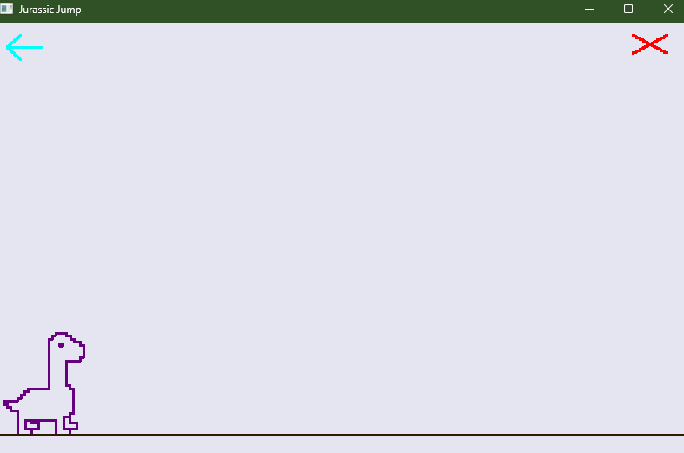

***Dinosaur Jump:***

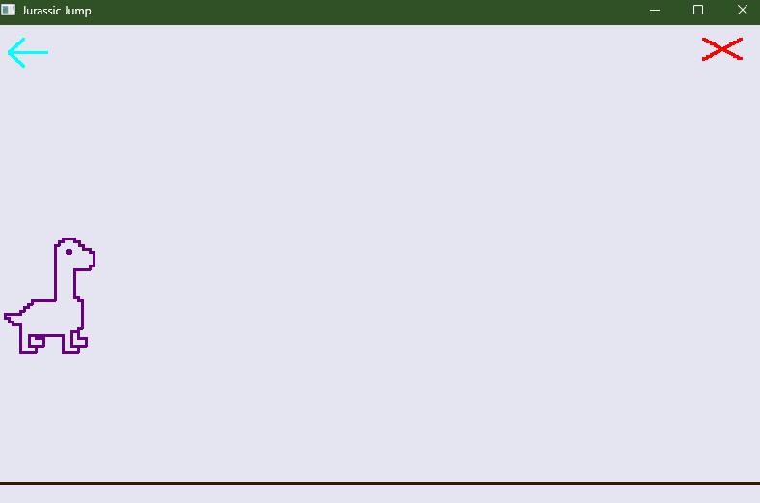

***Cactus and Bird Comes:***

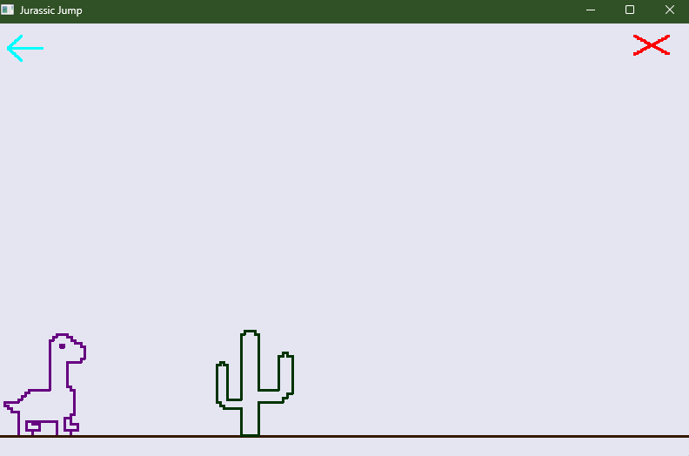

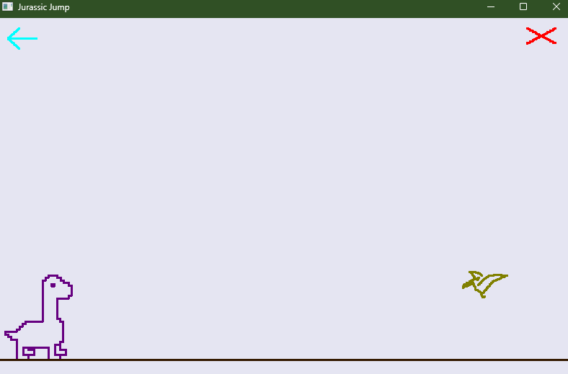

***Clashes:***

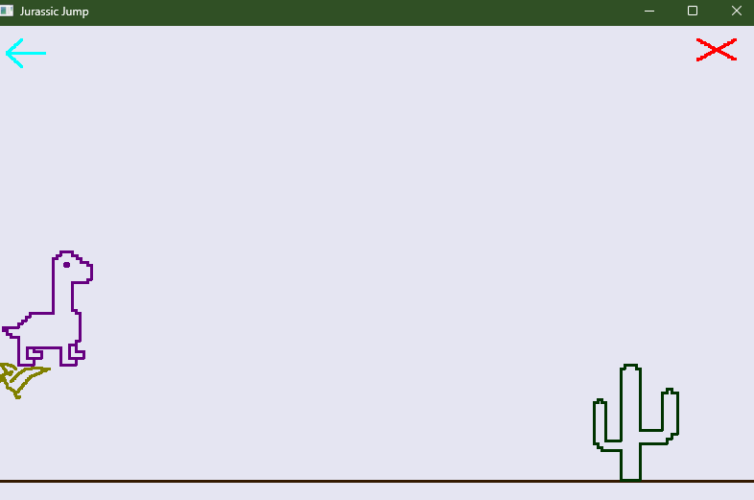

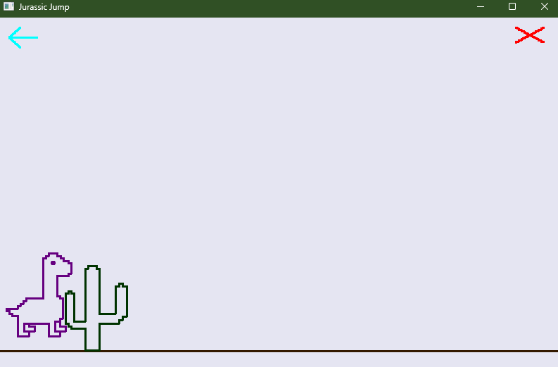

***Score Generates While Time Passes:***

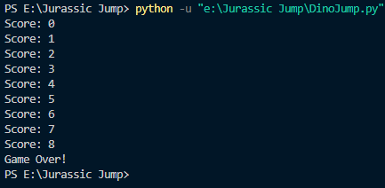

***The game restarts when the arrow button is clicked. The Game is crossed when the cross button is clicked.***